Verb Tense Practice
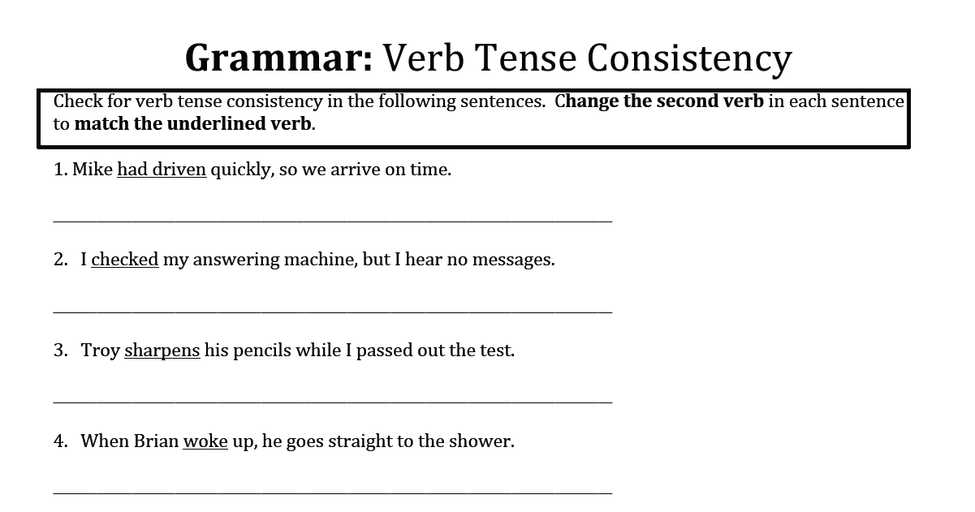
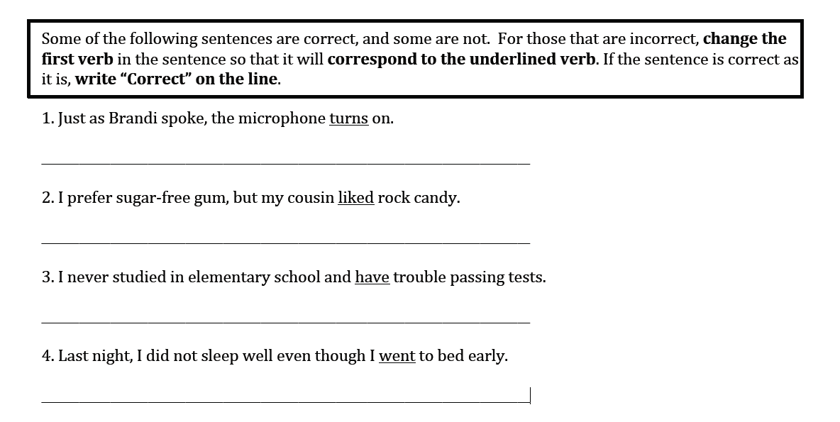
Verb Tense comparisons/discussions:
- Past tense vs. Past Perfect (drove vs. had driven) *NOT THE SAME
- Have/Has/Had = perfect tense
- HV + -ing ending = progressive tense
- HV’s purpose is to establish verb tense
- LV or HV (am, is, are, was, were, be, being, been)
- AV or HV (have, has, had, do, did, does, may, might, must, could, would, should, can, shall, will)

