Student Name
Asset Tag Number
Homeroom Teacher
School Name
Date
Title of Table
Name of Application, Website, and/or System | Description of Problem
Microsoft Word | Program will not open. Pop-up message states that I do not have permission.
http://cyoungresgmsd.weebly.com | All teacher websites like this one are blocked when trying to access at home.
System Preferences: Desktop Image | When I try to change Desktop Image in System Preferences, the image will not change. I guess that I do not have permission, but many of my peers can change theirs.
Printer | I do not have correct printer. (YOUNG RES)
Printer | I have too many printers listed and cannot delete wrong ones because I do not have permission.
System Preferences: Password | I cannot reset my password.

How to Make a Table in Word 2011 for Mac
Using the Ribbon to make a table in Word 2011 for Mac
Here’s how to insert a plain table by using the Tables tab of the Ribbon:
1. Click in your document to set the insertion cursor at the position where you want the new table to be placed.
2. Select the Tables tab on the Ribbon. In the Table Options group, click the New button.
3. Move the mouse cursor down and to the right across the grid.
4. Release the mouse to choose the number of rows and columns for your new table.
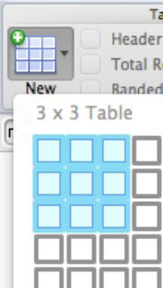

Using the mouse to create a table in Word 2011 for Mac
If you prefer to use the mouse whenever possible, you’ll love this method of creating and editing tables because it’s mostly click- and-drag:
- Choose Table→Draw Table from the menu bar. Alternatively, click the Draw button in the Draw Borders group of the Ribbon’s Tables tab.
- Drag the mouse diagonally to create a dotted box shape and then let go of the mouse button.
- Continue drawing row and column dividers by dragging the mouse horizontally and vertically.
- Click the Draw button in the Draw Borders group of the Tables tab of the Ribbon to restore normal mouse operation. Whenever you want to use the mouse to draw more rows, columns, or even another table, just click the Draw button. It’s a toggle switch between Word’s regular cursor and the table-drawing cursor. 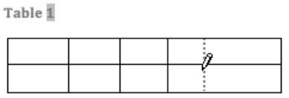

Using the Insert Table dialog in Word 2011 for Mac
This method uses a dialog to set the number of rows and columns to insert into your Word 2011 for Mac document:
- Click in your document to set the insertion cursor at the place where you want the new table to appear.
- Choose Table→Insert→Table. Alternatively, go to the Ribbon’s Table tab and choose New→Insert Table.
- Enter the number of rows and columns you want in the appropriate text boxes.
- (Optional) Decide on Autofit options: Initial Column Width: This defaults to Auto. When Auto is chosen, the table takes up as much room as is available in the document. Autofit to Contents: When you click inside the table and start typing, the cells will automatically size themselves to fit the contents. Autofit to Window: The same as Initial Column Width set to Auto. (Optional) If you know you’ll create more tables with these options, select the Set as Default for New Tables check box.
- Click OK to close the Insert Table dialog.

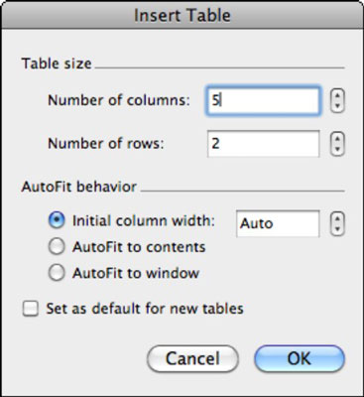

Add or delete rows or columns in a table

Add a row
You can add a row above or below the cursor position.
- Click where you want to add a row, and then click the Table Layout tab.
- Under Rows & Columns, click Above or Below.
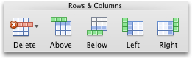
TIPS:
- You can also use the Draw tool to draw a row in a selected table. On the Tables tab, under Draw Borders, click Draw, and then draw a line through a row.
- To add a row at the end of a table, click the last cell of the last row, and then press the TAB key.
Delete a row
- Click a row or cell in the table, and then click the Table Layout tab.
- Under Rows & Columns, click Delete, and then click Delete Rows.
Add a column
- Click a column or cell in the table, and then click the Table Layout tab.
- Under Rows & Columns, click Left or Right.

Delete a column
- Click a column or cell in the table, and then click the Table Layout tab.
- Under Rows & Columns, click Delete, and then click Delete Columns.

Resize all or part of a table
You can resize a whole table to improve readability or to improve the visual effect of your document. You can also resize one or more rows, columns, or individual cells in a table.
Resize a table
- On the View menu, click Print Layout or Publishing Layout.
- Click the table.
- Rest the pointer on the lower-right corner of the table until appears, and then drag the table boundary until the table is the size that you want.
Change the row height in a table
- On the View menu, click Print Layout or Publishing Layout.
- Rest the pointer on the row boundary that you want to move until appears, and then drag the boundary until the row is the height that you want.
If you have text in a table cell, the row must be the same height or taller than the text.
TIP: To display row height measurements on the vertical ruler, click a cell, and then hold down OPTION as you drag the boundary.
Change the column width in a table
- On the View menu, click Print Layout or Publishing Layout.
- Rest the pointer on the column boundary that you want to move until appears, and then drag the boundary until the column is as wide as you want.
If you have text in a table cell, the column must be as wide as or wider than the text.
TIP: To display column width measurements on the horizontal ruler, click a cell, and then hold down OPTION as you drag the boundary.
Make multiple rows or columns the same size
- Select the columns or rows that you want to make the same size, and then click the Table Layout tab.
- Under Cell Size, click Distribute Rows or Distribute Columns.
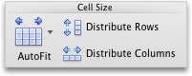
Change the space between cells in a table
- Click the table, and then click the Table Layout tab.
- Under Settings, click Properties.
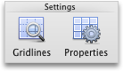
- Click the Table tab, and then click Options.
- Under Default cell spacing, select the Allow spacing between cells check box, and then enter the measurement that you want.

Align a table or text within a table
Align a table on a page
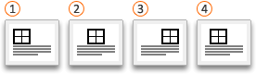
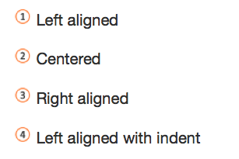
- Click the table, and then click the Table Layout tab.
- Under Settings, click Properties.
- Click the Table tab, and then under Alignment, select the option that you want.
TIP: To indent a left-aligned table, enter a number in the Indent from left box.
Align text within a table
- Select one or more cells in the table, and then click the Table Layout tab.
- Under Alignment, click Align, and then select the option that you want.
