Summer Reading Project
That Was Then This Is Now by S.E. Hinton

***Basic Collaborative Lesson – did not pass Comprehension Assessment (AR Test)***
(Completion of Summary Sections qualifies for retake of comprehension assessment)

Note: Use the rubric to guide project requirements.

Part 1
Directions: Create a six-part tri-fold brochure on the computer using Microsoft Word program to create a trifold for each of the following categories:
- The title, author, picture, and genre (front cover of trifold)
- Summarize Chapters 1-3
- Summarize Chapters 4-8
- Summarize Chapters 7-9
- Summarize Chapters 10-11
- Create a scene or find pictures that represent each of the summarized chapters (labeled)

Part 2
Answer the following questions using complete sentences – answer all parts of each selected questions. Use examples and details from the book to support your answers (Text-based Evidence Responses).

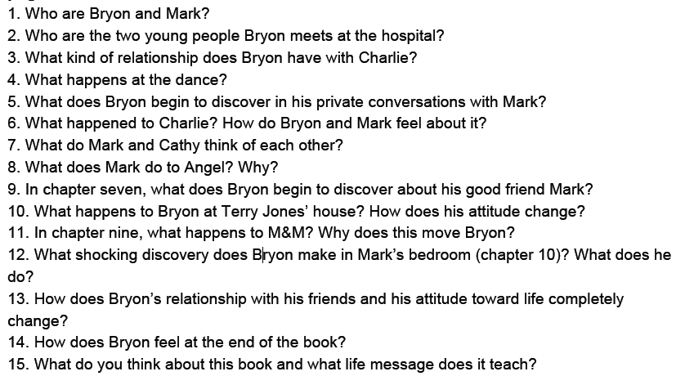
PLAGARISM WILL RESULT IN A ZERO. NO INTERNET SEARCHES FOR NOVEL INFORMATION FOR THIS ASSIGNMENT.

USE ONLY THE NOVEL, PEER DISCUSSIONS, AND SKILLS INFORMATION.
Brochure Rubric | 4 | 3 | 2 | 1
Cover Section | Accurately presents each of the following: Title, Author, Genre, Picture | Missing one of the following: Title, Author, Genre, Picture | Missing two of the following: Title, Author, Genre, Picture | Missing three of the following: Title, Author, Genre, Picture
Chapters 1-3 Summary Section | Original and accurate at least 10 sentences and complete summary of chapters 1-3. (5 W's and H questions) | Original and accurate fewer than 10 sentences but complete summary of chapters 1-3. (5 W's and H questions) | Original and accurate 5-10 sentences but incomplete summary of chapters 1-3. (5 W's and H questions) | Original and accurate fewer than 5 sentences and incomplete summary of chapters 1-3.
Chapters 4-6 Summary Section | Original and accurate at least 10 sentence complete summary of chapters 4-6. (5 W's and H questions) | Original and accurate fewer than 10 sentences but complete summary of chapters 4-6. (5 W's and H questions) | Original and accurate 5-10 sentences but incomplete summary of chapters 4-6. (5 W's and H questions) | Original and accurate fewer than 5 sentences and incomplete summary of chapters 4-6.
Chapters 7-9 Summary Section | Original and accurate at least 10 sentence complete summary of chapters 7-9. (5 W's and H questions) | Original and accurate fewer than 10 sentences but complete summary of chapters 7-9. (5 W's and H questions) | Original and accurate 5-10 sentences but incomplete summary of chapters 7-9. (5 W's and H questions) | Original and accurate fewer than 5 sentences and incomplete summary of chapters 7-9.
Chapters 10-11 Summary Section | Original and accurate at least 10 sentence complete summary of chapters 10-11. (5 W's and H questions) | Original and accurate fewer than 10 sentences but complete summary chapters 10-11. (5 W's and H questions) | Original and accurate 5-10 sentences but incomplete summary chapters 10-11. (5 W’s and H questions) | Original and accurate fewer than 5 sentences and incomplete summary of chapters 10-11.
Picture Representation Section | Picture of a scene or variety of pictures that accurately represent each of the four (4) chapter summary sections. (Identify chapter summary section for each picture.) | Picture of a scene or variety of pictures that represent only of the three (3) chapter summary sections. (Identify chapter summary section for each picture.) | Picture of a scene or variety of pictures that represent only two (2) chapter summary sections. (Identify chapter summary section for each picture.) | Picture of a scene or variety of pictures that represent only one (1) of the chapter summary sections. (Identify chapter summary section for picture.)
Attractiveness & Organization | The brochure has exceptionally attractive formatting and well-organized information. | The brochure has attractive formatting and well-organized information. | The brochure has well-organized information. | The brochure's formatting and organization of material are confusing to the reader.
Conventions of Writing | There are no grammar, capitalization, spelling, or punctuation mistakes in the brochure. | There are 1-2 grammar, capitalization, spelling, or punctuation mistakes in the brochure. | There are 3-4 grammar, capitalization, spelling, or punctuation mistakes in the brochure. | There are numerous grammar, capitalization, spelling, or punctuation mistakes in the brochure.
Content - Accuracy | All facts in the brochure are accurate and original student work. (No plagiarism has been detected.) | Only 1-2 minor errors in the brochure, but all original student work. (No plagiarism has been detected.) | Only 3-4 minor errors in the brochure, but all original student work. (No plagiarism has been detected.) | Numerous errors in the brochure, but all original student work. (No plagiarism has been detected.)
Questions Rubric | 4 | 3 | 2 | 1
Complete Sentences | All answer responses are in complete sentences. | Most answer responses are in complete sentences. | Some answer responses are in complete sentences. | Few answer responses are in complete sentences.
Text-Based Evidence Answers | Restated question, used at least 2 direct quotes, clearly explained answer using text. | Restated question, used only 1 direct quote, explained answer using text. | Restated question, used only 1 direct quote or failed to explain answer using text. | Restated question, but missing direct quote or explanation using text.
15 Questions (alternate scale points 8 point category and deduct for each question not answered.) | Completely answered all 15 questions. (No part unanswered) | Completely answered 14 questions. (No part unanswered) | Completely answered 13 questions. (No part unanswered) | Completely answered 12 questions. (No part unanswered)
Conventions of Writing | There are no grammar, capitalization, spelling, or punctuation mistakes. | There are 1-2 grammar, capitalization, spelling, or punctuation mistakes. | There are 3-4 grammar, capitalization, spelling, or punctuation mistakes. | There are numerous grammar, capitalization, spelling, or punctuation mistakes.
Digital Brochure Score ________/36 x 2 +8 = ___________
Questions Score ________/20 Final Project Score _______________

(Completion of Summary Sections qualifies for retake of comprehension assessment)
Original AR Test Score _____________ Retake AR Test Score ______________

